1. 
2. Let’s learn about environment and variables in postman.
3. Let’s first learn what environments are.
4. 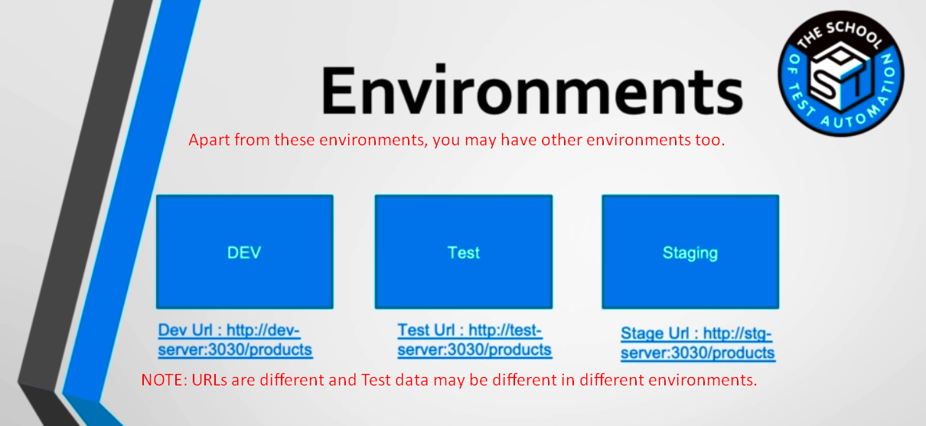
5. Let’s create a scenario where we want to fetch product info from each environment.  
   Now to maintain three different requests (URLs are different) is not a good practice.  
   Now what happens if something that is common in three different environment changes?
6. **Solution**: Postman provides environment feature.